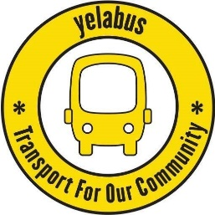

**Tasks relating to Recruiting & Inducting Volunteer Driver**

**Initial Interest**

Contact potential driver and arrange to meet at a mutually convenient time and place (normally a public place) – to be undertaken by Operations Manager (OM).

Explain what being a Volunteer Driver entails

Ask them to complete a personal details form

Take a copy of driving licence (Must hold a D1)

Arrange for them to shadow a couple of runs to see if they would still like to proceed

**DBS**

Is carried out via RVS and done via email OM to Bev, giving the drivers name and email address is sufficient, Bev does the rest.

**Midas**

Midas training is booked via RVS by the OM.

**Operational Training**

The Operations Manager (OM) to take trainee driver through the following documents / procedures:

* Health & Safety Policy
* Safeguarding Policy
* Completion of log sheet for each operation, particularly identifying any dead mileage operated and other details needed to aid monthly reporting
* Incident recording and reporting (to cover items other than accidents)
* Insurance arrangements – particularly details to hand over in the event of an incident
* Employers’ Liability Insurance certificate
* Covid-19 operating procedures or any other special procedures (if appropriate)
* Disciplinary and Grievance Procedure
* Hedgecroft procedures to access vehicle
* Policy in relation to driver age limits and frequency of MiDAS refreshers
* Briefing on legal basis of operation under S19 – need to check disk in place
* Briefing on equipment within vehicles
* Pre-operation vehicle check – what to look for and what to report
* Refuelling arrangements and responsibilities
* What to if there are spills or waste – full cleaning is not part of driver duties
* Manual handling – essentially do not and be careful if any items look potentially heavy
* Cleaning – not part of driver remit but liaise with OM if cleaning needed

(These are all noted on the New Driver Checklist or part of the log sheet process)

OM to arrange for the new driver to accompany some of our experienced drivers on their runs with the intention of practical knowledge alongside the above theoretical information. Once they have completed their MiDAS they can also drive the bus while accompanying the booked driver. This can occur as many times as they wish to build their confidence and give them a good foundation. It is recommended that at least one final trip undertaken by the new driver is attended by OM to give final approval as “yelabus approved”.